For returning Club members, you will notice a new look to our website and registration process this year. The Vashon Island Soccer Club has moved its website platform from Korrio to Blue Sombrero. We hope that this transition will be smooth and simple for all users, but please let us know if you experience difficulties by contacting us at registrar@vashonsoccer.org. The following instructions will guide you through the registration steps.

1. Visit Vashonsoccer.org and click the “register” buttom to create a user name and password.

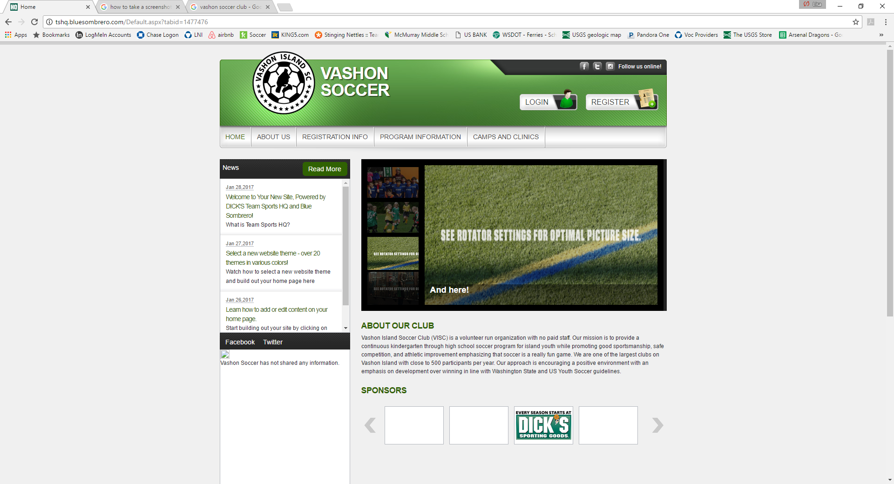

1. You will then be directed to the website’s 4-step process beginning with a Primary Parent/Guardian section. This is filled out by you with your information. (Participants come later).

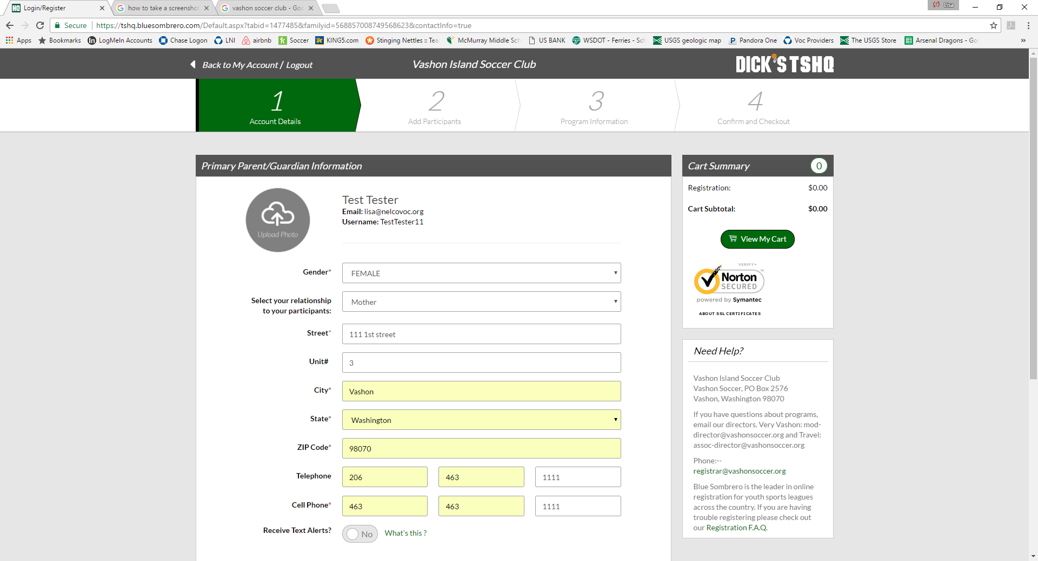

1. Click “create additional account user and continue” and it will take you to choose what “best describes you”? Choose one.

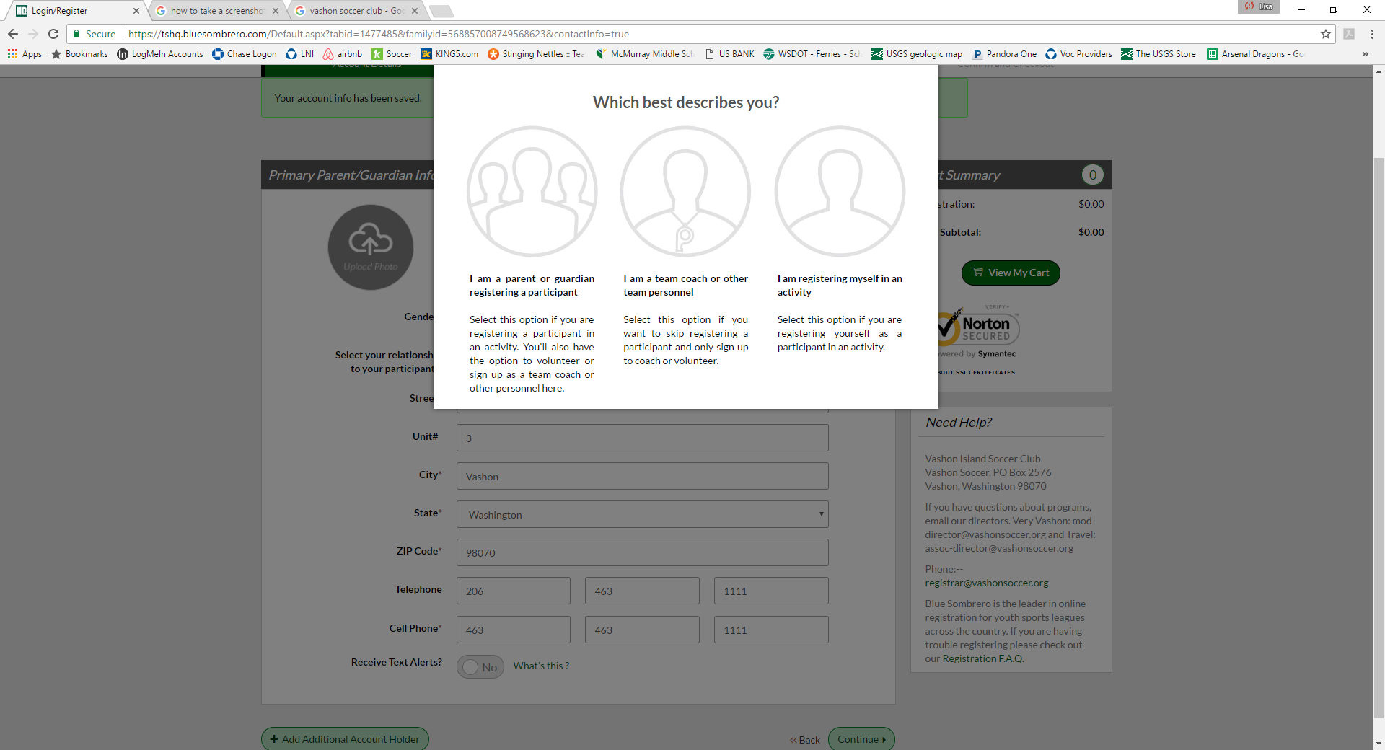

1. To register a **player** click inside the first circle. This will take you to step 2.

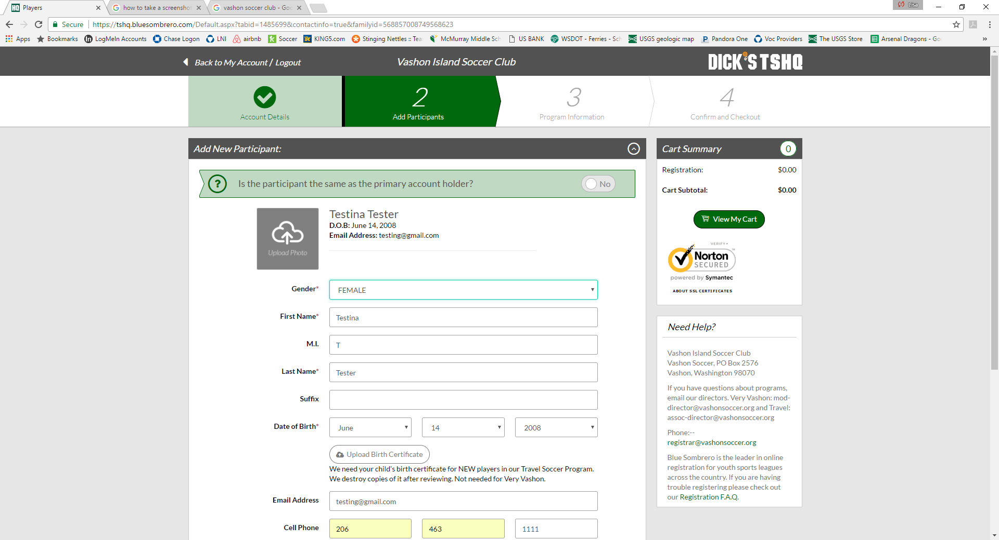

1. Complete the player information requested. **A government-issued identification is required to verify date-of-birth for all players from birth years 2007 -2000. Returning players that have previously submitted birth verification to Vashon Island Soccer Club are exempt.**  Click continue.

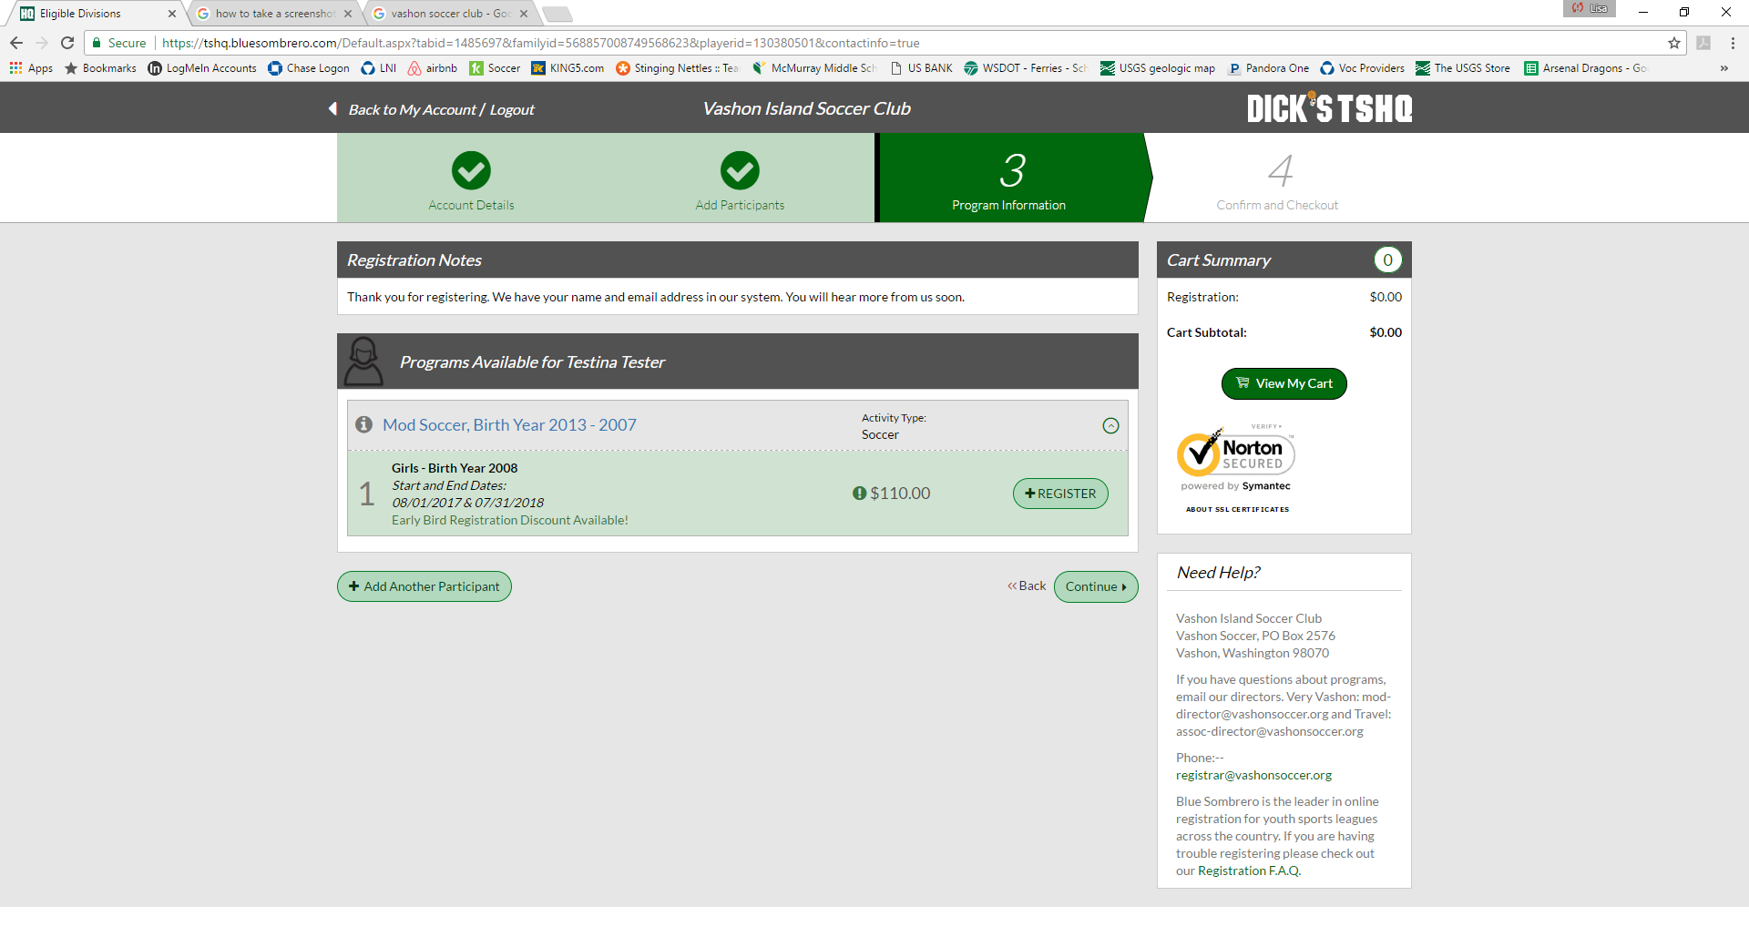

1. Click “Add Another Participant” from the bottom left bubble for more players. Or, click “register” if no more participants.

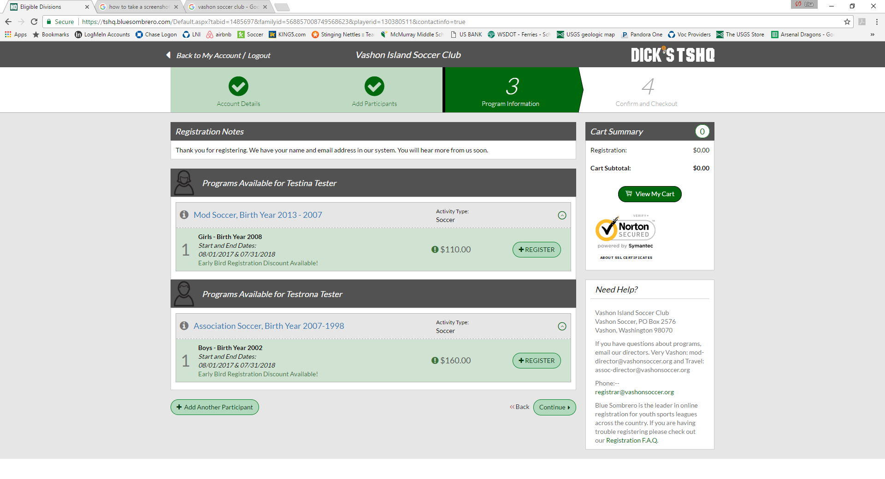

1. Once you have completed information for all players, click the “+ register” button for each participant. Continue.

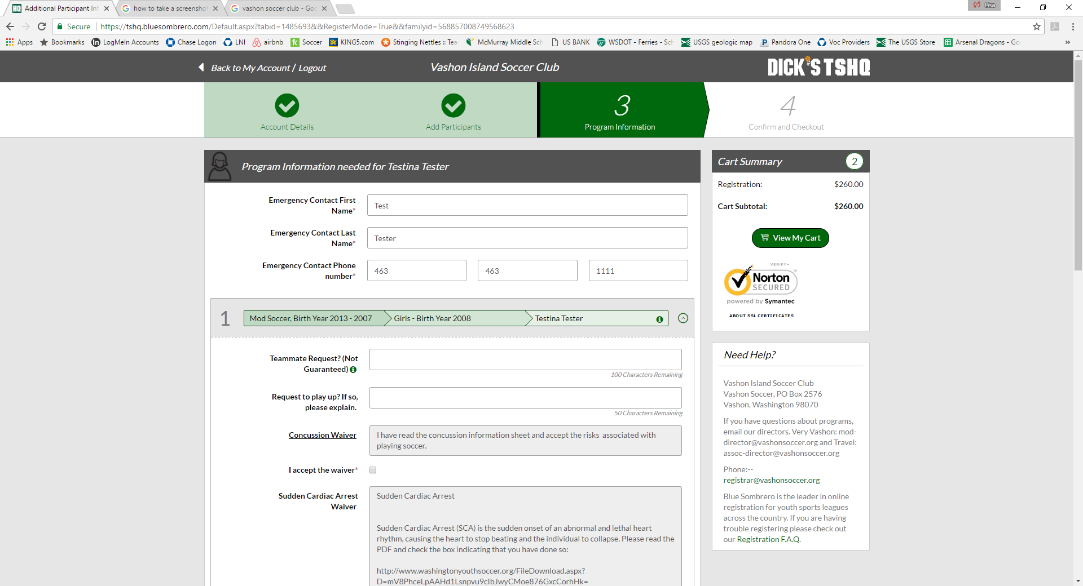

1. You now have the opportunity to provide emergency contact l information and requests for each participant and review and sign the concussion and cardiac arrest waivers. Request for scholarship is also available on this page. (For “play-up” policy please see the tab under “About Us” on the home page). Continue.

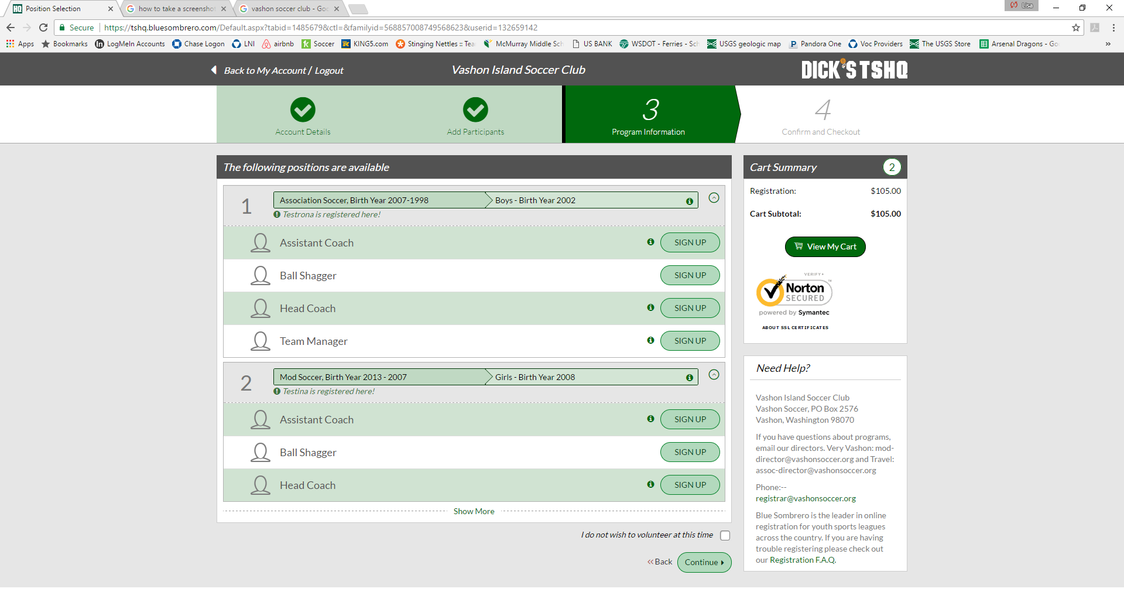

1. Vashon Island Soccer Club relies on volunteers and helpers to function. We value and support each other’s participation. Please consider committing to be part of the upcoming season with the gift of your time and energy. Click continue.

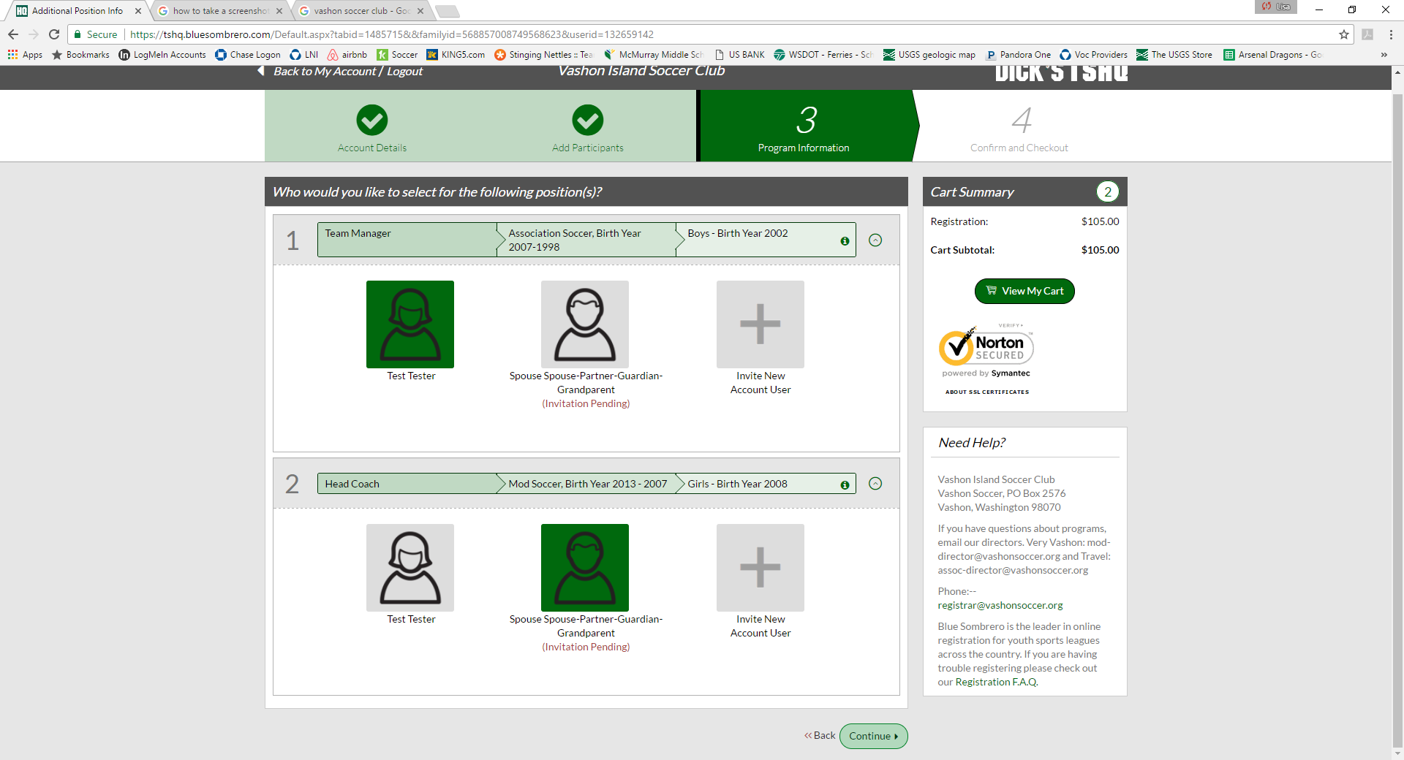

1. On this screen you can choose the participation of you or whom you select to volunteer. Continue. Complete information and answer questions. The process will direct you to your cart for check out.

Thank you for your patience!